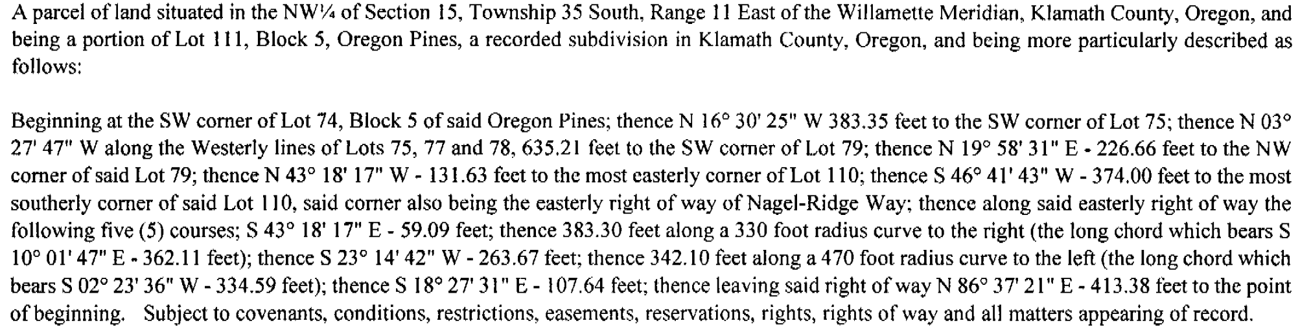

Oregon Pines Block 5 lot111 complete legal

